**Project Initialization and Planning Phase**

| Date | 06 JULY 2024 |
| --- | --- |
| Team ID | SWTID1720193784 |
| Project Name | Early Prediction Of Chronic Kidney Disease Using Machine Learning |
| Maximum Marks | 3 Marks |

**Define Problem Statements (Customer Problem Statement Template):**

One of the issues that healthcare providers encounter when dealing with patients is early recognition of those who are likely to develop CKD, therefore, take the appropriate preventive measures. CKD is frequently characterized by its ability to maintain the absence of symptoms until the later stages, thus making it difficult to diagnose. Late presentation therefore leads to worsened patient health, higher costs of treating such patients, and a drain on the limited health resources.

Thus, we require a robust, stable, and fast solution that can predict the development of CKD based on the clinical attributes in its early stage. Our goal is to use advanced artificial neural network approach and formulate a model that can assess patients’ data, pinpoint the potential signs of complications, and give alerts to doctors. This solution should fit well into our current healthcare practice and not impose much complexity on the medical staff, it must provide observations that allows early intervention thus increase the quality of the patient’s prognosis and decrease the long term expenses incurred in management of CKD.

Reference: <https://www.kidney.org/atoz/content/about-chronic-kidney-disease>

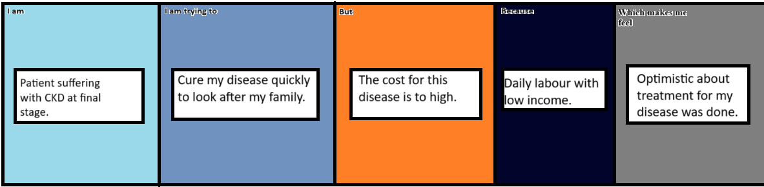

|  |  |  |  |  |  |
| --- | --- | --- | --- | --- | --- |
| **Problem**  **Statement (PS)** | **I am**  **(Customer)** | **I’m trying to** | **But** | **Because** | **Which makes me feel** |
| PS-1 | Patient suffering with CKD at final stage. | Cure my disease quickly to look after my family. | The cost for this disease is to high. | Daily labour with low income. | Optimistic about treatment for my disease was done. |